1a-2 Ubuntu Desktop and Command Line Familiarisation

Class Activity Overview
This session introduces students to the Ubuntu Desktop and emphasises command-line use. Students will explore file navigation, permissions, network tools, user management, and software installation via GUI and CLI.

Learning Objectives
- - Understand the Ubuntu desktop and basic command-line interface (CLI).
- - Use basic terminal commands for navigation, file handling, and user management.
- - Explore system information, process monitoring, and networking tools.
- - Understand software installation via GUI, APT, and source compilation.
- - Compare public/private IPs and experiment with host configuration.
- - Develop beginner C program and compile using GCC.

Part 1: Ubuntu Desktop GUI Familiarisation
- - Check Internet using Firefox.
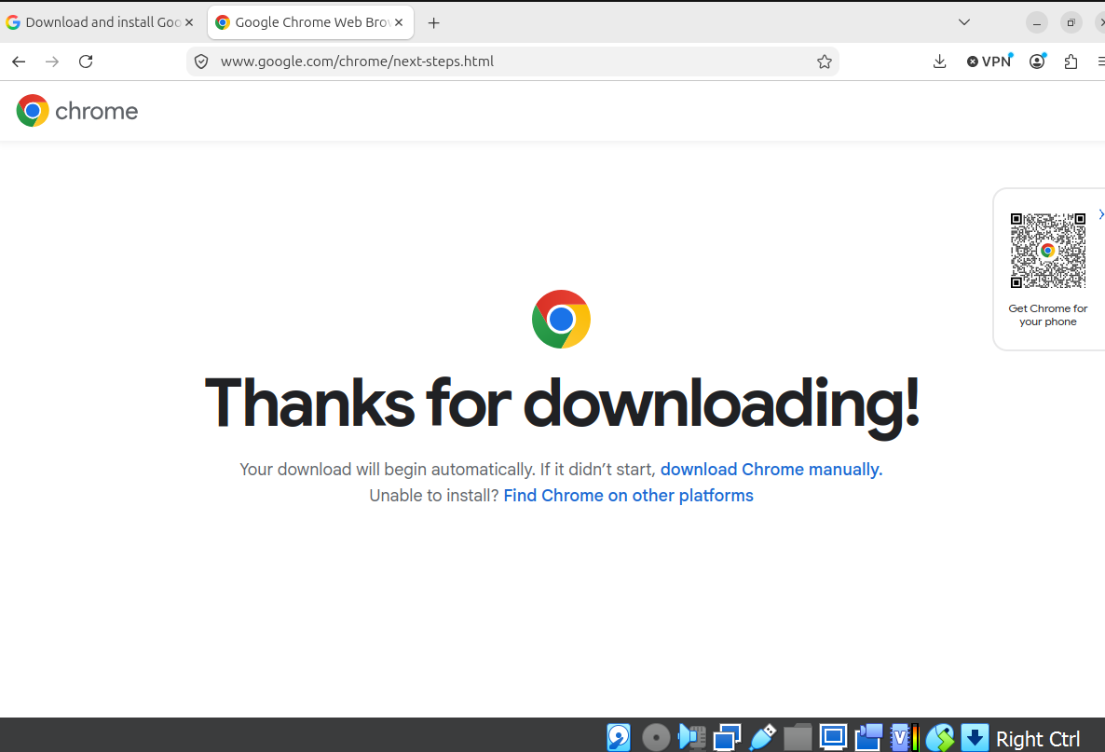
- - Open LibreOffice and type a document.
- 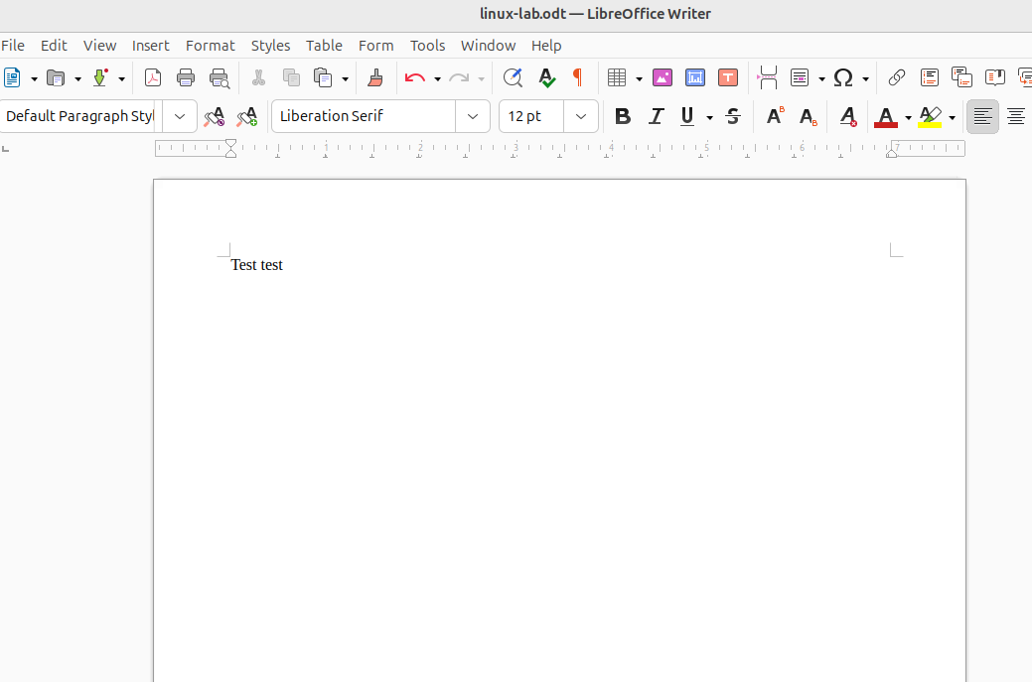
- - Navigate directories using File Manager.
- 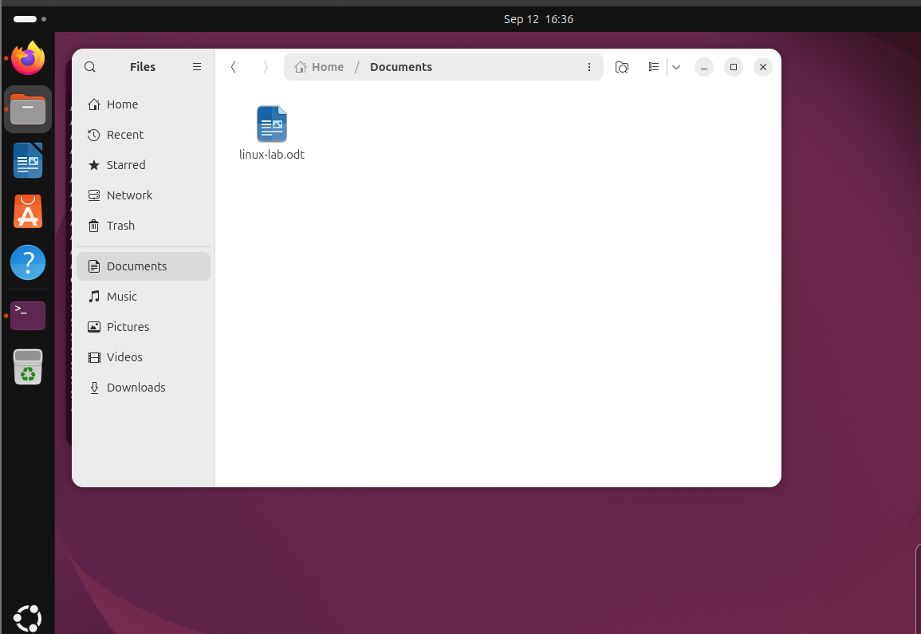
- - Install a program via Ubuntu Software Centre.
- - Visualise file changes by placing terminal and file browser side-by-side.
- 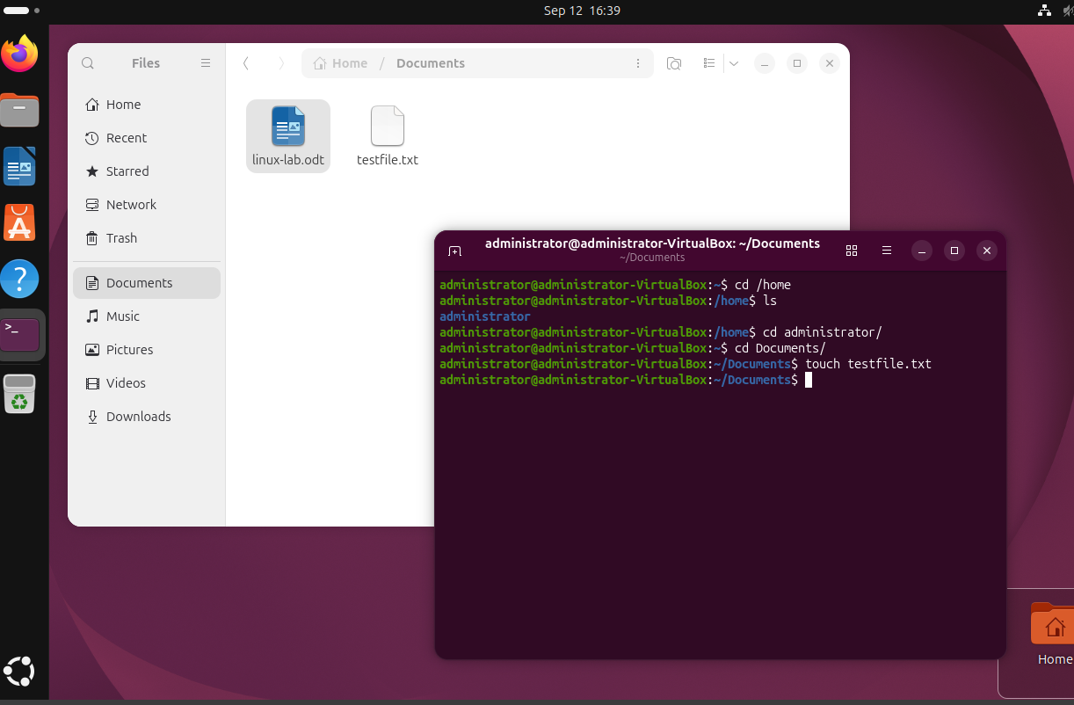

Part 2: CLI Basics and File Operations
- - Use `ps -e`, `top`, and `1` to monitor processes.
- - Use `ls`, `ls -la`, `ls -alt`, `ls -lah` to explore files.
- - Create/edit/view files using `touch`, `gedit`, `nano`, `cat`, `less`.
- - Copy and move files with `cp`, `mv`; delete with `rm`.
- 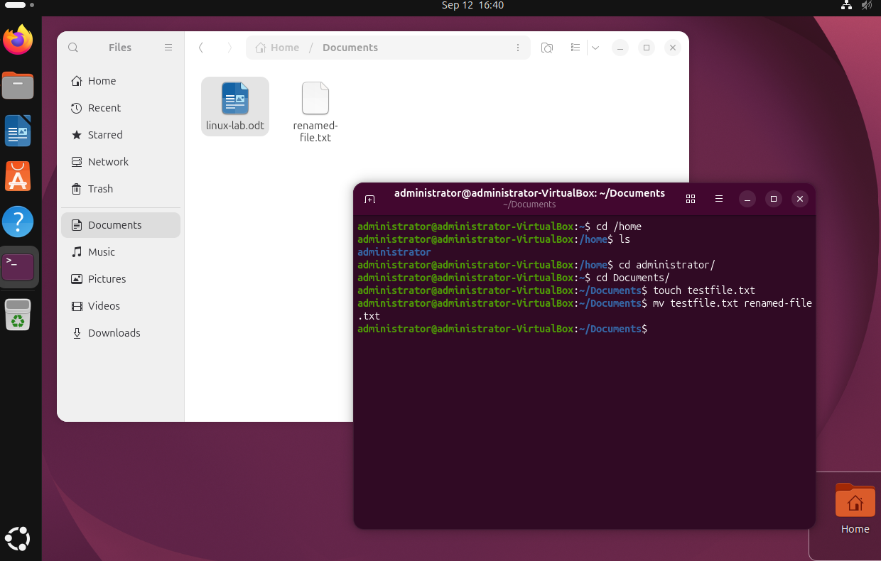
- 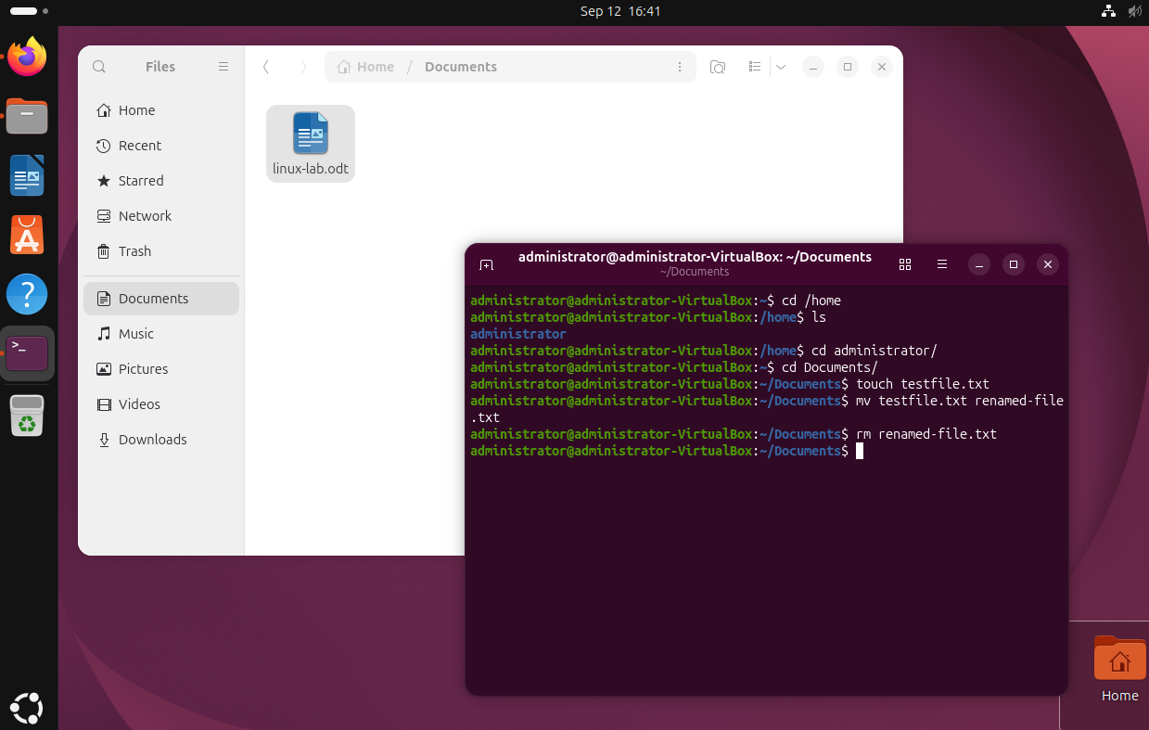
- View system info using `uname -a`, `lsb_release -a`, `hostnamectl`.
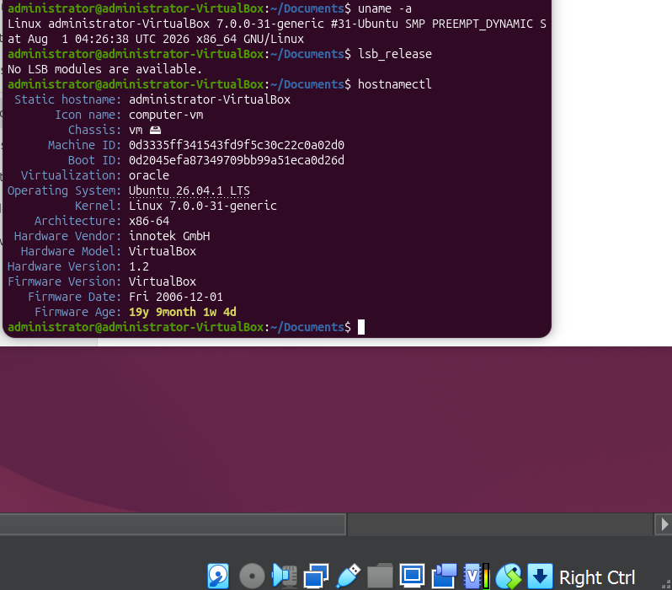

Part 3: Super User and Permissions
- - Use `whoami`, `sudo whoami` to demonstrate privilege escalation.
- 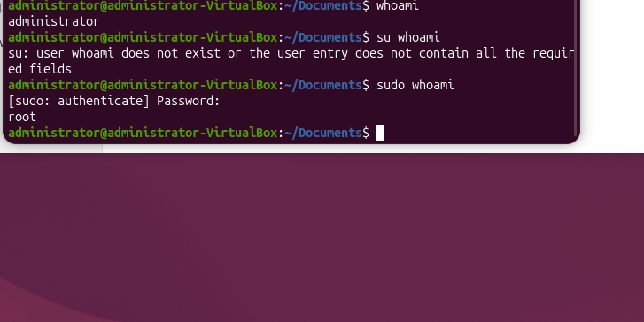
- - Attempt `adduser` as sudoregular user, then with `sudo`.
- 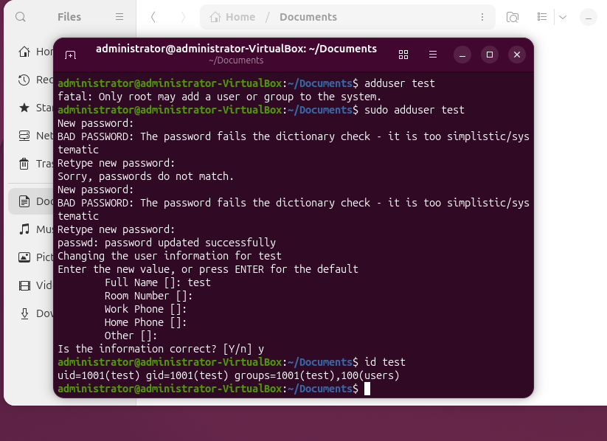
- - Discuss role of root user and best practices for privilege use.

Part 4: Network Configuration and DNS
- - Use `ip a` to identify private IP.
- - Ping local devices or 8.8.8.8 and discuss DNS.
- - Edit `/etc/hosts` to create custom aliases; test with `ping`.
- - Use `nslookup` and install/use `whois` to investigate domains.
- - Compare public/private IP via https://whatismyipaddress.com/.

Part 5: System and Hardware Info
- - Use `lsusb`, `lspci`, `less /proc/cpuinfo` to inspect hardware.
- - Compare CLI outputs with 'About This Computer' in settings.
- - Redirect output using `>`, e.g., `lsusb > output_of_lsusb`, then view with `less` and `cat`.

Part 6: Software Installation Methods
- - Install a browser (Chrome/Opera) from a .deb file.
- 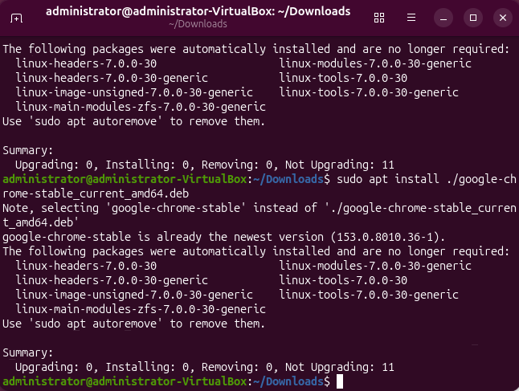

- - Install apps via Ubuntu Software Centre.
- - Use `sudo apt update`, `sudo apt upgrade`, `sudo apt install vlc`.
- 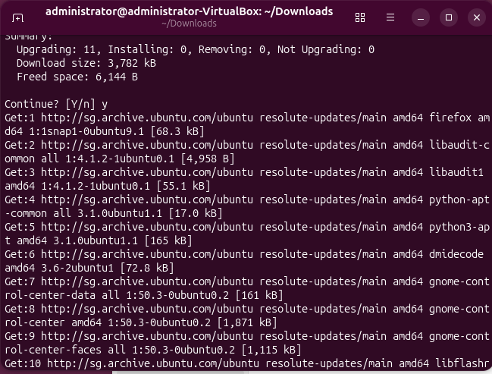

- - Search packages with `sudo apt search [keyword]`.
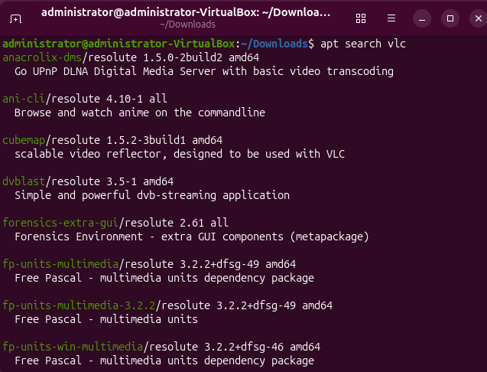
- - Explore `/etc/apt/sources.list` to discuss trusted repositories.
- 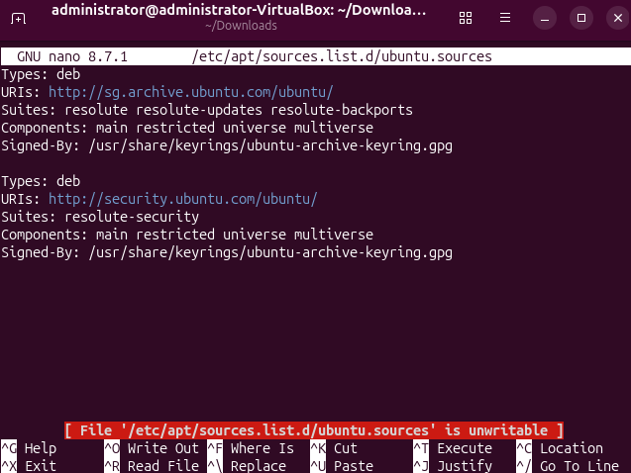

Part 7: Compiling from Source (Optional)
- - Install build tools: `sudo apt install build-essential`.
- - Write a basic `hello_world.c` and compile with `gcc`.
- - Run the executable with `./hello_world_executable`.
- - Adjust permissions with `chmod 777` if needed.
- - Compare source and compiled file using `less`.

Reflection Questions
- - Which file editors are best for remote access and why?
- - Compare software installation methods: SaaS vs binaries vs repos vs source.
- - What are pros/cons of each method from user and developer perspectives?
- - How did using CLI improve your understanding of Linux?

🖥️ Activity: Ubuntu GUI & CLI Familiarisation + Software Installation Methods
📘 Objective
Develop working knowledge of the Ubuntu Linux environment via GUI and CLI. Learn software installation methods, basic networking, file permissions, and compiling from source.

📦 Deliverables
# | Deliverable | Description
✅ 1 | GUI Familiarisation Proof | Screenshots of:  • Firefox opened and working  • LibreOffice with text typed  • File manager navigating directories  • Software installed via Ubuntu Software Centre
✅ 2 | Terminal Commands Output | Evidence of CLI exploration, e.g., output screenshots or logs for:  • ps -e, top, ls, ls -la, ls -alt  • File creation and editing with touch, nano, gedit, cat, less
✅ 3 | File Operations Practiced | Screenshot or terminal output showing use of:  • cp, mv, rm and file listing with size (ls -lah)
✅ 4 | System Information Commands | Output or screenshots of:  • uname -a, lsb_release -a, hostnamectl, /proc/cpuinfo
✅ 5 | User Privilege Experiment | Terminal output showing:  • whoami, sudo whoami  • Attempting to adduser without and then with sudo
✅ 6 | Networking Tests | Evidence of:  • ip a output  • Successful ping to local IP or 8.8.8.8  • Screenshot of Ubuntu network settings window
✅ 7 | /etc/hosts File Edited | Screenshot of:  • sudo nano /etc/hosts editing  • Successful ping GoogleEpicDNS
✅ 8 | DNS Lookup Performed | Output of:  • nslookup google.com  • whois google.com
✅ 9 | Public vs Private IP Reflection | Screenshot of ip a and result from https://whatismyipaddress.com/ with 1–2 lines explaining the difference
✅ 10 | Hardware Info Commands | Output or screenshot for:  • lsusb, lspci, less /proc/cpuinfo  • Comparison with GUI “About this Computer”
✅ 11 | Output Redirection Practiced | Screenshot of:  • Command lsusb > output_of_lsusb  • Viewing output with less, cat  • Deleting it with rm
✅ 12 | Software Installed (3 Ways) | Evidence of all three:  • SaaS (e.g. login to Office 365 or Google Docs in browser)  • Binary download (e.g., .deb file like Chrome/Opera)  • Repository install via Ubuntu Software Centre
✅ 13 | Command-Line Install via apt | Evidence of:  • sudo apt update and sudo apt upgrade  • sudo apt install vlc or other package  • Optional: less /etc/apt/sources.list
✅ 14 | Source Code Compilation | Deliverables:  • File hello_world.c with source code  • Compilation using gcc hello_world.c -o hello_world_executable  • Execution with ./hello_world_executable  • If needed: chmod 777 for permission fix
✅ 15 | Reflection Summary (Paragraph) | A short reflection (100–200 words) covering:  • GUI vs CLI experience  • Software installation methods pros/cons (SaaS, repo, manual, source)  • Your preference as a user and as a future software developer

📝 Suggested Submission Format:
- A single .zip file containing:
  - Screenshots (named clearly by step)
  - Terminal output logs (optional)
  - Source code file: hello_world.c
  - Compiled file: hello_world_executable (optional)
  - Written reflection in .txt, .md, or .docx

